3.2 The Derivative as a Function Worksheet

- Find the derivative of the function using the definition of the derivative. State the domain of the function and the domain of its derivative.

has a domain of .
has a domain of .

has a domain of .
has a domain of .

has a domain of .
has a domain of .
- The graph of the function is shown below.
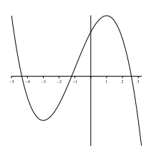

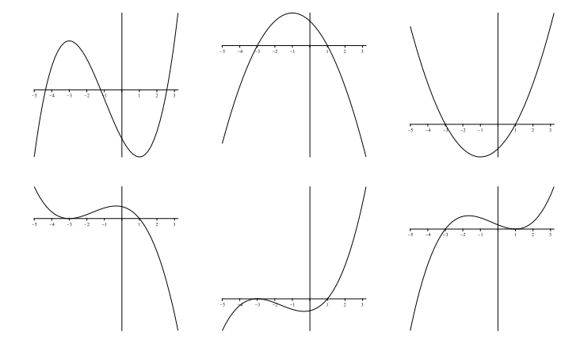
One of the six graphs below is the graph of . Circle the graph of .

- Match the graph of each function in (a) – (d) with the graph of its derivative in I-IV.
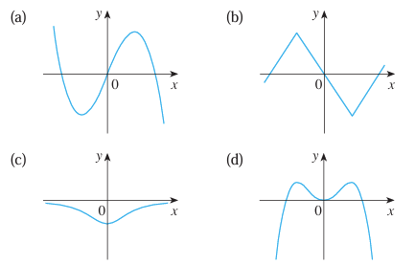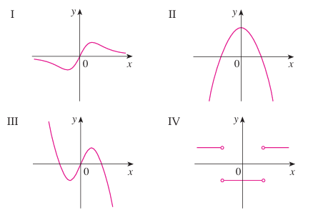
- We match this graph with II.
- We match this graph with IV.
- We match this graph with I.
- We match this graph with III.

- The graph of f is given. State, with reasons, the numbers at which f is not differentiable.
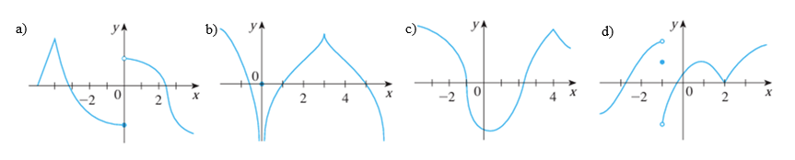
- f is not differentiable at .
At there is a corner point and not tangent line can be drawn.
At the function has a jump discontinuity and therefore no tangent line can be drawn to model the behavior of the curve on both sides of .

- f is not differentiable at .
At there is an infinite discontinuity and therefore the function is not defined. So, no tangent line can be drawn at .
At the function has a cusp. No tangent line can be drawn to model the behavior of the curve on both sides of .

- f is not differentiable at .
At the function appears to have a vertical tangent line here which would have an undefined slope.
At the function has a cusp. No tangent line can be drawn to model the behavior of the curve on both sides of .

- f is not differentiable at .
At the function has a jump discontinuity and therefore no tangent line can be drawn to model the behavior of the curve on both sides of .
At the function has a cusp. No tangent line can be drawn to model the behavior of the curve on both sides of .
- Suppose that we know that is an even function that is differentiable at . we know that has the following values:
Find .

Since is even then . Since is differentiable at then is continuous at .
So, .

- TRUE or FALSE: If a function is continuous at , then must exist.

This is false. A counter example here would be at . is continuous at but is not differentiable there and therefore, does not exist.

